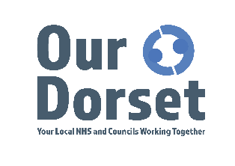

Dorset COVID-19 Vaccination Programme – Frontline Health and Care Staff
Vaccines are the way out of this pandemic. An effective vaccine is the best way to protect people from coronavirus.
Following extensive trials, two safe and effective COVID-19 vaccines have been approved in the UK and the NHS COVID-19 vaccination programme has started in Dorset.

An independent group of experts (Joint Committee of Vaccination and Immunisation) has
recommended that the NHS first offers these vaccines to those at highest risk of catching the
disease and of suffering serious complications or dying from COVID-19. Read the latest JCVI advice on priority groups for the COVID-19 vaccination on GOV.UK

The NHS is planning to ensure that everyone in the top four priority groups identified by the
JCVI – including all frontline NHS and care staff – are offered their first vaccination by the
middle of February.

Who is eligible?
Chapter 14a of the COVID Green Book gives us a definition as to which health and social care staff are deemed as frontline

The objective for vaccination of frontline health and care staff is to protect workers at high risk of exposure who provide care to vulnerable individuals.

How will staff get a vaccine?
Together we’re working to coordinate our approach to vaccinating frontline NHS and care staff and are aiming to offer access to first vaccinations to all staff who meet the criteria by the middle of February.

Where will we access our vaccinations?
We are working to co-ordinate capacity so that all within the priority groups 1-4 can receive their vaccination as soon as possible. Staff who are considered as deemed as frontline will be given dates to access their vaccine at an appropriate site after registering.

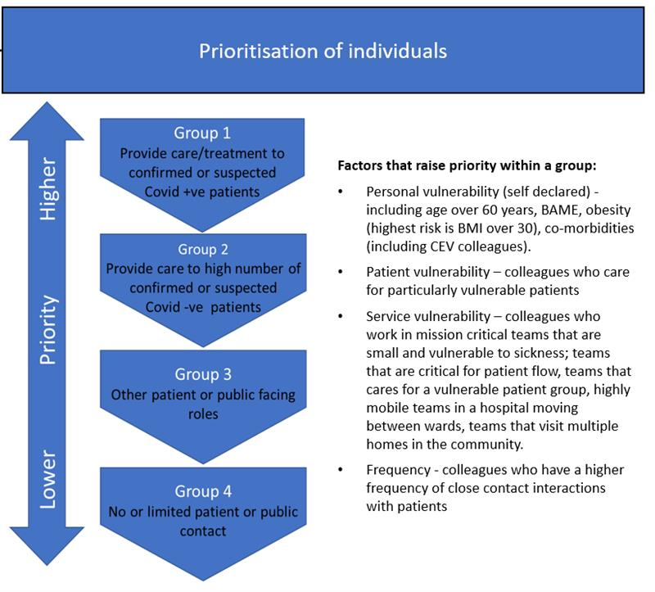
Figure 1: Prioritisation of individuals for vaccination

What action do I need to take?
We are asking each organisation to nominate a Lead Contact who can work with our booking teams to identify numbers of staff in your teams and cascade dates and information to those staff members in your team.

Please complete this online form to advise us of the numbers of staff in your team who require the vaccine and what categories they fall into to enable us to prioritise. Once submitted, you will receive an email notification advising you of your teams’ booking and one of our central bookings team will be in touch with you soon.

This piece of work is a priority for the health and care system in Dorset and we’re working in partnership to ensure you receive your vaccine as soon as possible.

For more information about the Coronavirus (COVID-19) vaccine, please visit the NHS website.

Thank you
Staff Vaccination Central Booking Team
StaffVaccination@DorsetCCG.nhs.uk

