**Fun and Light Relief – Get Involved**

* Coronovirus Gruffalo Cartoons

<https://www.theguardian.com/books/gallery/2020/apr/04/gruffalo-axel-scheffler-and-julia-donaldsons-coronavirus-cartoons>

* Activate Performing Arts  - Dorset based arts group with a range of resources and information on arts during the coronavirus <https://activateperformingarts.org.uk/covid19>
* The Sofa Singers Free weekly online singing event <https://www.thesofasingers.com> register and each week there will be a different song
* Disability Arts  - Online Weekly online social to tackle isolation you need to register first using the email [joe@disabilityarts.online](mailto:joe@disabilityarts.online) <https://disabilityarts.online/events/disability-arts-online-presents-weekly-online-social/>
* Poole Museum - A range of resources including virtual tours <http://www.poolemuseum.org.uk/> Thursday @ 10.30am virtual coffee and chat by zoom Adults
* Twome - Instagram macramé account <https://www.instagram.com/_twome/> - Weekly tutorials
* Stitch and Story - Free how to knit and crochet tutorials <https://www.stitchandstory.com/pages/knitting-video-tutorials>

Education & Learning

* Birds of Poole Harbour - Osprey webcam <https://www.birdsofpooleharbour.co.uk/osprey/osprey-webcams/>
* AFC Bournemouth Community Trust - Activity packs for children to help with numeracy and literacy <https://www.afcb.co.uk/news/community/educate-your-children-with-activity-packs/>
* BBC Newsround 100 activities to do in lockdown <https://www.bbc.co.uk/newsround/52227592>
* African Activities - Videos on how to make things from recycled materials <https://africanactivities.org.uk/recycling-resources-for-your-classroom>

Health & Wellbeing

* Action for Happiness - Advice and guidance on how to stay well during the lockdown <https://www.actionforhappiness.org/10-keys-to-happier-living>
* Golden Carers - 50 activity suggestions for the elderly during lockdown <https://www.goldencarers.com/50-activities-for-the-elderly-in-lockdown-and-isolation/6265/>
* Dance plug - Online free dance classes <https://www.danceplug.com/class/free>
* The Mix -  Support service for young people <https://www.themix.org.uk/>
* Good Finance - Resources for staying in touch virtually, adapting to new working patterns and looking after your mental health. <https://www.goodfinance.org.uk/latest/post/coronavirus-post/connectivity-and-remote-working> (useful for charities/social enterprise)

Diverse Communities

* Travellers Times - Coronavirus advice and guidance edition <https://www.travellerstimes.org.uk/sites/default/files/paragraphs/filelink/TT-Corona-final-final-LR.pdf?fbclid=IwAR0VEVy8tiIt9ba-5sezgZ1SmNUGkf8LdIDEXO0WF7RF0zL1Xs_5qE4dVtM>
* LGBT+ Traveller Pride  - Traveller LGBT+ support group  <https://www.lgbttravellerpride.com/>
* Black South West Network (BSWN) - Bristol based BAME support network with a range of information advice and guidance <https://www.blacksouthwestnetwork.org/>
* Muslim Council of Britain - National umbrella body of over 500 mosques, educational and charitable associations. <https://mcb.org.uk/> specific coronavirus support information during Ramadan <https://mcb.org.uk/resources/ramadan/>
* Ask Doc - tips to stay safe - videos in a range of languages from this Manchester based health professional BAME group <http://askdoc.org.uk/events/covid-19/> (Eng, Punjabi, Mirpuri, Bengali, Arabic, Pushto, Kurdish Sorani, Farsi, Urdu, French, Turkish, Polish, Romanian, Swedish, Sylheti Bengal)

**Community Support Resources**

As Attached Posters at the end of this document:

* **Help for households experiencing difficulties with their heating** and electricity CAB
* **Scams** – How to recognise them and where to report them when identified.
* **Domestic Abuse** – where to find help in Dorset
* **Eating and Drinking Well in Later Life** – Bournemouth University
* **How to access food in an emergency** – Dorset Council
* **How To Talk About Alcohol** – Discussion Guide for Health Care Providers - from REACH
* **Are you Juggling Caring and Working**? – Dorset Healthcare Universities Foundation Trust
* **Mental Health Support** Telephone Numbers Dorset Carers Support
* **Carers support and prescription collection** – Dorset Carers Support
* **Carers Support and Shopping** – Dorset Carers Support
* **Feeling Lonely or isolated** - New Friendship Line run through PramaLife
* **How to access Drug and Alcohol Services** (REACH) during COVID -19 Lockdown
* **Coronavirus and Your Health** – Tips for looking after your physical and mental health – RETHINK

**Public Health England Campaigns Resources**

<https://campaignresources.phe.gov.uk/resources/campaigns/101-coronavirus-/resources>

**COVID-19 Information**

* **GOV.UK WhatsApp Coronavirus Information Service:** A new GOV.UK WhatsApp Coronavirus Information Service has now been launched. The purpose of this product is to combat the spread of misinformation propagated through WhatsApp on an Official Government channel. To use the service, simply add +44 7860 064422 to their contacts and send a WhatsApp message saying “Hi”. Please promote this service through your channels.
* **Coronavirus fact sheet for children:** [Information for children](https://campaignresources.phe.gov.uk/resources/campaigns/101/resources/5093)to help them understand what Coronavirus is, the importance of hand washing and how to help stop the virus spreading is available on the Campaign Resource Centre.This was developed by the Alder Hey Children's NHS Foundation Trust. They have also made an [animation](https://youtu.be/iMR3WPCRuAI) to go with it.
* **With today the start of Ramadan, colleagues in Public Health have asked if the following public health message could be shared amongst Muslim communities:** The message from health experts and Muslim leaders as communities across England prepare to celebrate Ramadan is to stay at home to help stop the spread of coronavirus and protect families and the wider community. <https://publichealthmatters.blog.gov.uk/2020/04/22/stay-at-home-for-ramadan/>

In addition, the Muslim Council of Britain have published advice on how to celebrate Ramadan during COVID-19 and this is available on their [website](https://mcb.org.uk/resources/ramadan/). Also, information about COVID-19 in other languages is available on both the [Doctors of the World](https://www.doctorsoftheworld.org.uk/coronavirus-information/) website and [gov.uk](https://www.gov.uk/government/publications/coronavirus-covid-19-information-leaflet) website.

* **Testing for Key Workers Guidance**

<https://www.gov.uk/guidance/coronavirus-covid-19-getting-tested>

**Mental Health**

 At the Veterans Conference in London this was highlighted as a new project that was being developed to be released in June; the launch has been brought forward and has happened today!

<https://www.gov.uk/government/news/new-mental-fitness-tool-launched-to-help-military-enhance-mental-wellbeing>

What is HeadFIT and who is it for?

* HeadFIT has been developed in partnership with The Royal Foundation's Heads Together campaign, the Ministry of Defence and King's College London.
* HeadFIT is a new online platform, which will provide the military with 24/7 access to self-help tools to help them manage the stresses of everyday life. **It is also suggested that it is a great resource for any frontline staff at this time and as no login is required there appears to be no barriers to use.**
* The platform includes tools such as breathing exercises, body posture and relaxation techniques that have been designed for all defence personnel, whether they are new recruits, long-serving personnel, veterans, civilian staff or those in uniform. The techniques are designed so they can be easily integrated into their everyday lives.

Check it out here: <https://headfit.org/>

**Every Mind Matters**



<https://www.nhs.uk/oneyou/every-mind-matters/>

The coronavirus (COVID-19) outbreak means that life is changing for all of us for a while. It may cause you to feel anxious, stressed, worried, sad, bored, lonely or frustrated. It's important to remember it is OK to feel this way and that everyone reacts differently. Remember, this situation is temporary and, for most of us, these difficult feelings will pass.

There are some simple things you can do to help you take care of your mental health and wellbeing during times of uncertainty. Doing so will help you think clearly, and make sure you are able to look after yourself and those you care about

**10 tips to help if you are worried about coronavirus**

<https://www.nhs.uk/oneyou/every-mind-matters/coronavirus-covid-19-anxiety-tips/>

**Looking after children and young people during the coronavirus outbreak**

<https://www.nhs.uk/oneyou/every-mind-matters/looking-after-children-and-young-people-during-coronavirus-covid-19-outbreak/>

**7 simple tips to tackle working from home**

<https://www.nhs.uk/oneyou/every-mind-matters/7-simple-tips-to-tackle-working-from-home/>

**Mental wellbeing while staying at home**

<https://www.nhs.uk/oneyou/every-mind-matters/coronavirus-covid-19-staying-at-home-tips/>

**Coronavirus and Your Health** – Tips for looking after your physical and mental health – RETHINK As Attached poster

**Podcast for carers to help with self care** during the pandemic developed in partnership with Dorset Healthcare carers lead, Dorset Mental Health Forum, Rethink and the Recovery Education centre.

<https://soundcloud.com/user-186630975/am-i-a-carer-or-am-i-just-a-mum-a-daughter-a-son-a-wife-a-husband-a-friend>

**Community Support**

**What to do if you cannot afford or access food for you and your family-**

**There is help available for people who are registered as Shielded or extremely vulnerable**

If someone is “Shielded” that means they have a medical condition and have had a letter from the NHS saying they need to take special care. To be Shielded:

- you have a medical condition which means you’re classed as being clinically extremely vulnerable to coronavirus

- you’ve been told by your GP or hospital clinician that you’re clinically extremely vulnerable and need to ‘shield’

The letter will have let them know that if they cannot afford food at this time they can access a free weekly government food parcel. They can register online with GOV.UK

<https://www.gov.uk/coronavirus-extremely-vulnerable> or telephone  **0800 028 8327**

If no parcel arrives please signpost them to this helpline number as Dorset Council have one-off emergency food parcels, they can get delivered to them.

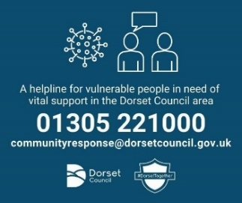

**There is help for anyone who cannot access food, medicine or other essentials.**

For anyone who needs help whatever their situation and is unsure what to do they can phone the local Dorset Council number **01305 221000** and get the support they need. These contact details are for anyone who needs help and who has no family, friends or community support.

**It is open and manned by Dorset Council Customer Services 8am to 8pm daily including weekends.** [**communityresponse@dorsetcouncil.gov.uk**](mailto:communityresponse@dorsetcouncil.gov.uk)

They will help people to sort any problems out and are working with partners so that they can direct and refer people to appropriate support. Importantly they can put in place support such as arranging food deliveries, medicine, etc and where people can afford food but cannot access it due to self-isolation, they can phone this number and be linked up with registered volunteers who can shop for them.

**Directory available** **co-ordinated by Help and Kindness**

Please make the public aware of a great website collating all help and support available including shops who will take payment over the phone and do deliveries. If you put COVID 19 and your postcode in the search terms you get all relevant local info and phone numbers.

Help and Kindness <https://www.helpandkindness.co.uk/>



**Work with other Foodbanks:**

All food banks are up and running and being supported by Dorset Council, attached is the current list which can also be found on the Council Website under Foodbanks (listed about half way down the page): Please direct people to their local area if they cannot afford food: [latest foodbank list](https://www.dorsetcouncil.gov.uk/care-and-support-for-adults/adult-social-care-pdfs/dorset-food-bank-information-directory-2020.pdf).

**How to cancel Government Food Parcels –**

If you have received an NHS letter and if you have [registered on the gov.uk website as shielding](https://www.gov.uk/coronavirus-extremely-vulnerable), you may have received a weekly food parcel. This will contain enough food for one adult for one week.

If you want to cancel this, do **ONE** of the following:

* Refuse the parcel when it is delivered, this will then cancel it and remove you from the government distribution list **OR**
* Go to the [gov.uk website where you registered as shielded](https://www.gov.uk/coronavirus-extremely-vulnerable), go to the question 'Do you have a way of getting essential supplies delivered at the moment'. You previously answered no to this question, please now reply as yes. You will then be removed from the government distribution list **OR**
* Call **0800 028 8327** and make sure you have your NHS number (this will be on the top of your NHS letter). This is an automated phoneline and you will need to follow the instructions. You will be asked the question 'Do you have a way of getting essential supplies delivered at the moment'. You previously answered no to this question, please now reply as yes. You will then be removed from the government distribution list

Please note that deregistering from the food parcels will not cause you to lose your priority status slot for supermarket delivery.



**COVID-19 and Emergency Local Assistance (ELA)**

ELA has been a valuable resource to Dorset residents for a number of years, providing practical and financial support to individuals and families in a time of crisis or extreme financial hardship.

In response to COVID-19 and to ensure that we continue to provide support to our communities in these uncertain times, the support that can be provided by ELA has changed slightly to reflect demand.

**What support is available?**

Now, rather than receiving a ready-made food parcel we are providing a pre-paid card that will allow you to purchase food and essentials for yourself and your family. If you are, however, in a position where you are self-isolating or you are having difficulty getting to the shops (e.g. mobility, transport) then we can make a referral to our partner agency Dorset First Point and they can collect the ‘essentials’ you require and drop-off at your property. Dorset First Point is also able to provide guidance around benefits, housing, budgeting or linking you to a more local resource in your community and will also check on your wider wellbeing.

We can also provide support with utilities. We will have a conversation with you to check that you have maximised any of the offers provided by your utilities provider, but if this is not an option, we will try to make a top-up payment on your behalf either over the phone or on-line whilst we are talking to you. If this is not an option with your particular energy supplier, we will again send out a pre-paid card. This can be with or without a referral to Dorset First Point depending on your circumstances.

Although food and utilities are the focus, if you are an organisation working with somebody who is experiencing circumstances such as leaving hospital or being housed temporarily, and they do not have the necessary basics at home (e.g. bed or cooker) please get in touch and we will see if we can help. There may be some funding available or we may be able to link you to other useful local resources.

**How to contact Emergency Local Assistance?**

ELA can be accessed as a self-referral or with the support of another organisation and can be accessed via telephone, Monday to Friday 8.30 – 5.00 on:

**0330 1234 225**

**Funding**

**Calling all East Dorset and Purbeck voluntary and community groups.**

57 voluntary and community groups in Dorset have been awarded just over £200,000 in emergency grants from the Dorset Coronavirus fund,

**but very few groups from East Dorset or Purbeck have applied**.

This means there is less money going to support vulnerable communities in your area. If you are a group supporting vulnerable communities in East Dorset and Purbeck, **NOW** is the time to apply. You can apply for up to £5,000 if you are a registered charity, or a constituted group online at any time, via a very straight forward application form. Decisions are made every fortnight, so you do not have to wait too long to receive those much needed funds. If your group is newly formed to support your local communities then you can still apply for up to £1,500 provided you have someone who will act as a referee, endorse your group and manage the funds on the groups behalf. You can apply to cover costs including;

* Volunteer expenses
* Capital equipment if you’ve had to purchase additional IT to support staff working from home
* PPE
* Telephone helplines,
* Food & medicine delivery
* Organisation core costs

You can even claim some costs already incurred (retrospective) if they were in urgent response to the crisis. Have a look at the DCF website to see some of the project costs that have already been funded. [https://www.dorsetcommunityfoundation.org/news/57-voluntary-groups-from-across-the-county-benefit-from-the-foundations-coronavirus-response-funding/](https://dorsetcommunityaction.us10.list-manage.com/track/click?u=8011bb15875ff3b88b5b2a0d1&id=bc6f20cf42&e=975d93a552)  
  
We want to make sure that all of Dorset benefits from the funds available. Not just for now, but in the future as well, helping groups like yours, weather this storm and continue to support communities and deliver services once this is over.  If you need help with the application form, please get in contact with DCA via [info@dorsetcommunityaction.org.uk](mailto:info@dorsetcommunityaction.org.uk)  
  
**Anita Hansen**  
**Community Advisor**  
**East Dorset Team**

**The following are the attached posters. These are not the originals but copies to save on email size. Should you want the original for printing off please email me** [**debra.pattinson@dorsetcouncil.gov.uk**](mailto:debra.pattinson@dorsetcouncil.gov.uk) **and I will send the original.**



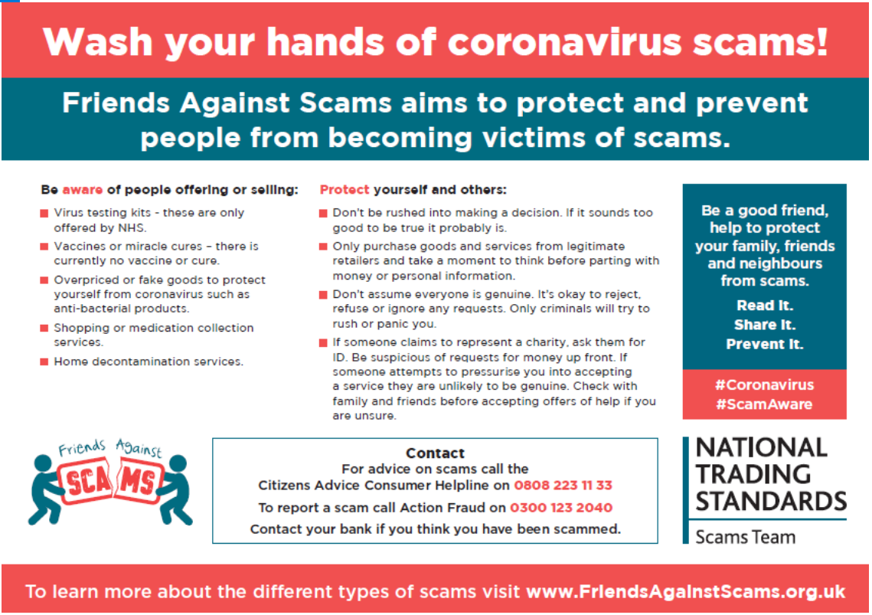

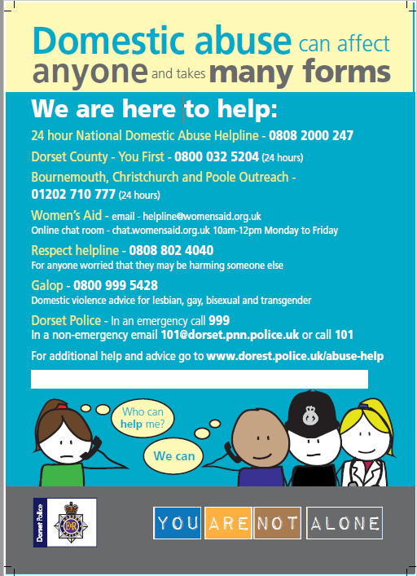

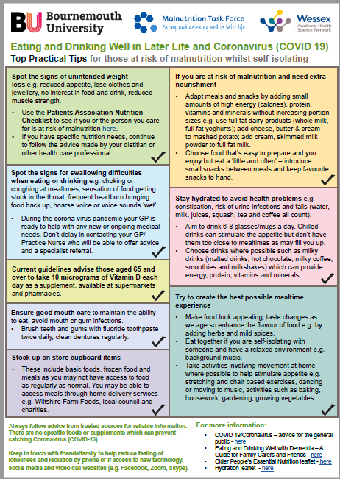

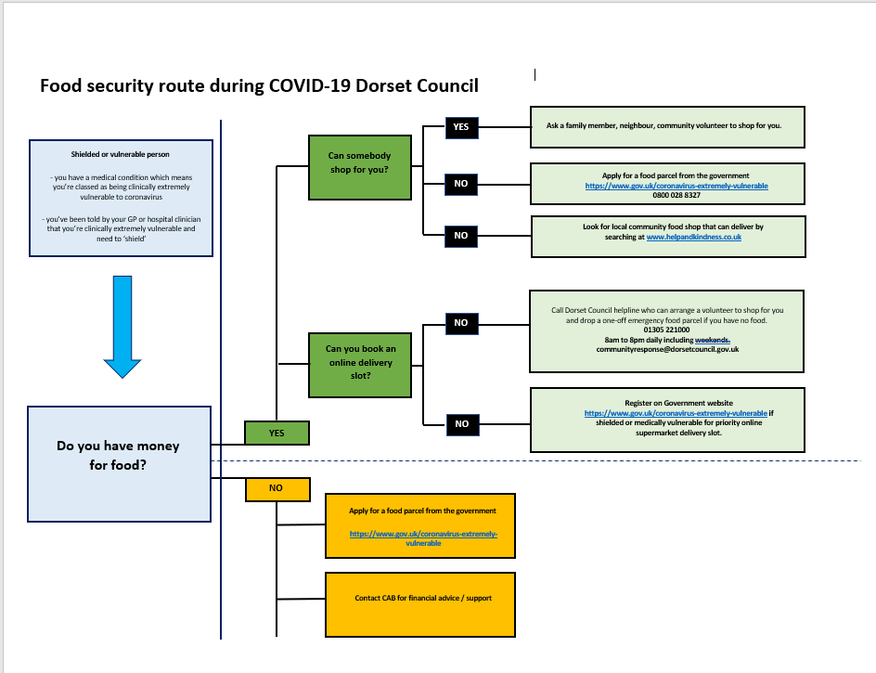



A Discussion Guide for Health Care Providers.

**Talking about Alcohol issues;**

Self-isolation may lead some people to drink more alcohol than usual, which may start to impact on their parenting.

The attached leaflet and Q&A’s below have been put together to try and encourage your service users to engage with REACH drug and alcohol services.

Many parents will not disclose the full extent of their drinking to health care professionals, in the fear they will be judged or it will have consequences.

It is important to try and have a positive conversation about the benefits of reducing their alcohol intake.

For Example;

Q – How do you feel the day after drinking alcohol?

A – I usually have a headache and feel hot and sweaty

Q – This must make it hard for you having to get up and get the kids breakfast ready? Reducing your drinking could improve your sleep and give you more energy to deal with your family.

**Q – How do you feel mentally the next day?**

**A – I always feel low the day after.**

**Q - Did you know alcohol is linked to a range of mental health issues, such as depression and memory loss? Reducing your drinking could improve your mood and give you more patience with your family.**

**For a more formal and comprehensive set of questions you could use the ‘severity of alcohol dependence questionnaire’ (SADQ) If answered honestly this can assess if there is a dependency to alcohol.**

<https://www.smartcjs.org.uk/wp-content/uploads/2015/07/SADQ.pdf>

If you have any further questions please do not hesitate to contact REACH on 0800 043 4656

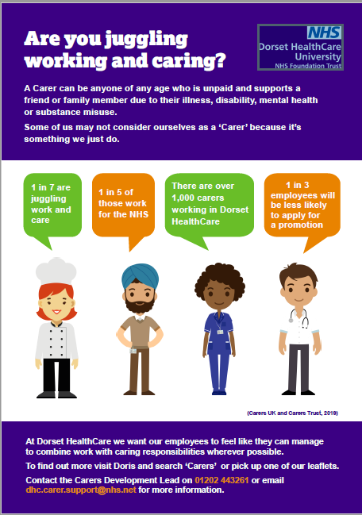

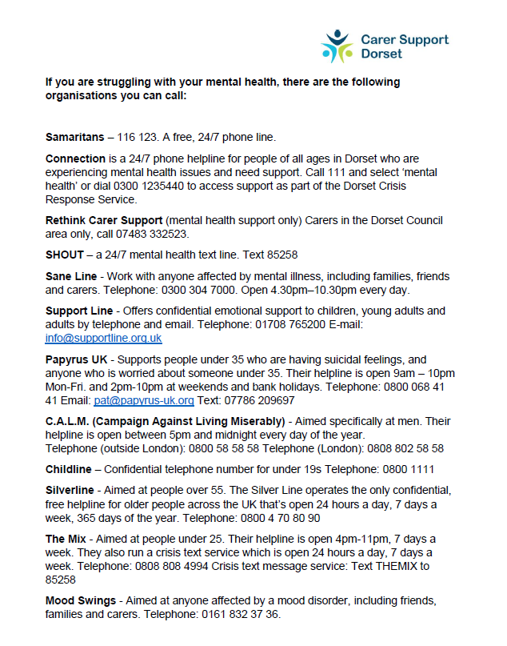

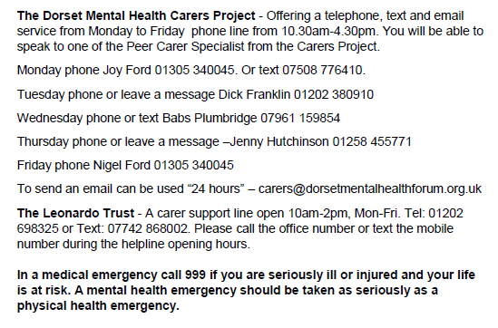

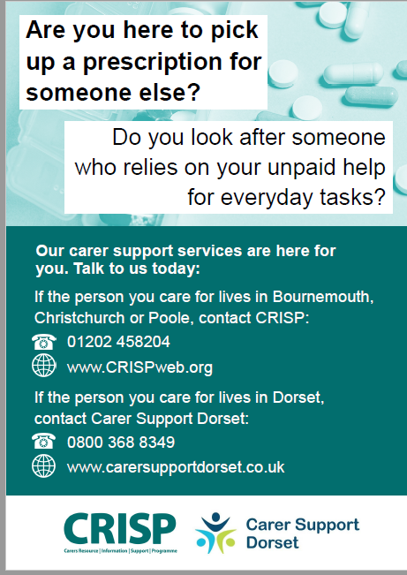

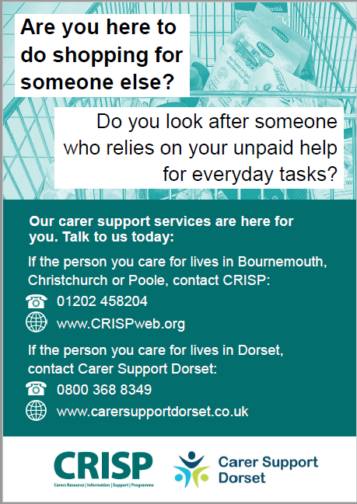

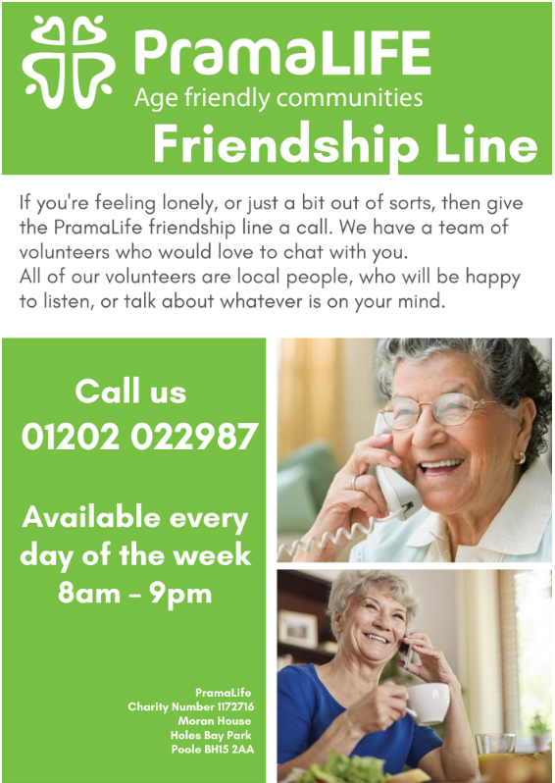

|  |  |  |  |  |  |  |  |  |
| --- | --- | --- | --- | --- | --- | --- | --- | --- |
| **Referral Process**  If you need advice or support related to alcohol or substance use, the first step is to call our SPOC helpline telephone number listed below.  A fully qualified member of staff will assist you with a telephone referral which is likely to include booking an initial assessment appointment.  This 1:1 telephone appointment is focused on your here and now, particularly what prompted your call and how alcohol and/or substance use is affecting you. It is also aimed at gathering information, in preparation for when you are allocated a Recovery Navigator so that time can be used to focus on your questions and concerns.  Your Recovery Navigator will then contact you to offer support and discuss the extra support available from our specialist family support team.  Alternatively you can call one of our Hubs direct:  **REACH WEST (Weymouth)** - **01305 571264**  **REACH NORTH (Gilliangham) - 01747 825872**  **REACH EAST (Christchurch/Wimborne) - 01202 482908**  Or complete an online referral form; [**https://pds.drugreferrals.com**](https://pds.drugreferrals.com ) |  | *“Before COVID-19 I had not had a drink for 42 days, I was working and enjoying an alcohol free life with my family. Then lockdown happened, I was furloughed, my routine and structured was taken away, I had to try and support my daughter who has struggles of her own. My mood became low, old habits returned and I lapsed. My Family Support Worker contacted me and I told her what had happened. She put a plan together for me which I am trying hard to stick to. I am using the online resources available to me and having weekly phone 1:1’s as well as workbooks emailed to me. Its still a struggle but I know the support is there for me when I need it”*  ADDITIONAL SUPPORT:  MUTAL AID MEETINGS online:  Alcoholics Anonymous [**https://www.alcoholics-anonymous.org.uk/AA-Meetings/Find-a-Meeting/Online**](https://www.alcoholics-anonymous.org.uk/AA-Meetings/Find-a-Meeting/Online)  Narcotics Anonymous [**https://online.ukna.org/**](https://online.ukna.org/)  Cocaine Anonymous [**https://www.ca-online.org/**](https://www.ca-online.org/)  All fellowships [**https://www.intherooms.com/home/**](https://www.intherooms.com/home/)  SMART Recovery [**https://smartrecovery.org.uk/online-meetings/**](https://smartrecovery.org.uk/online-meetings/)  AL-ANON – Family Support Group[**https://www.al-anonuk.org.uk/**](https://www.al-anonuk.org.uk/)  Domestic Abuse support **-** [**https://safelives.org.uk/**](https://safelives.org.uk/) **or https://www.nationaldahelpline.org.uk/** |  | |  | | --- | | **REACH Drug and Alcohol Services want to provide reassurance that, albeit in different times, we are still operating and available to provide support. This leaflet will detail services that we offer for families in the West, North and East of Dorset. How to refer into the service and provide harm reduction advice.**  *“When I heard I was no longer able to access the REACH Drug and Alcohol project due to COVID-19, I became scared and anxious. I didn’t think I would be able to maintain my recovery, as well as look after my children. As all the worries were going around my head I received a text message from my family support worker, letting me know she was just at the end of the phone and if I needed any support to just give her a call. The text came at the exact moment I needed it and they kept coming! I receive a weekly phone call from her and my recovery worker, she sends encouraging texts most days and emails with resources for me and the kids. If I ever have a wobble and there have been a few! I know the support is still there for me”* | |  | |  | |  | |