TOP TIPS - HOW TO GET THE BEST FROM YOUR APPOINTMENT
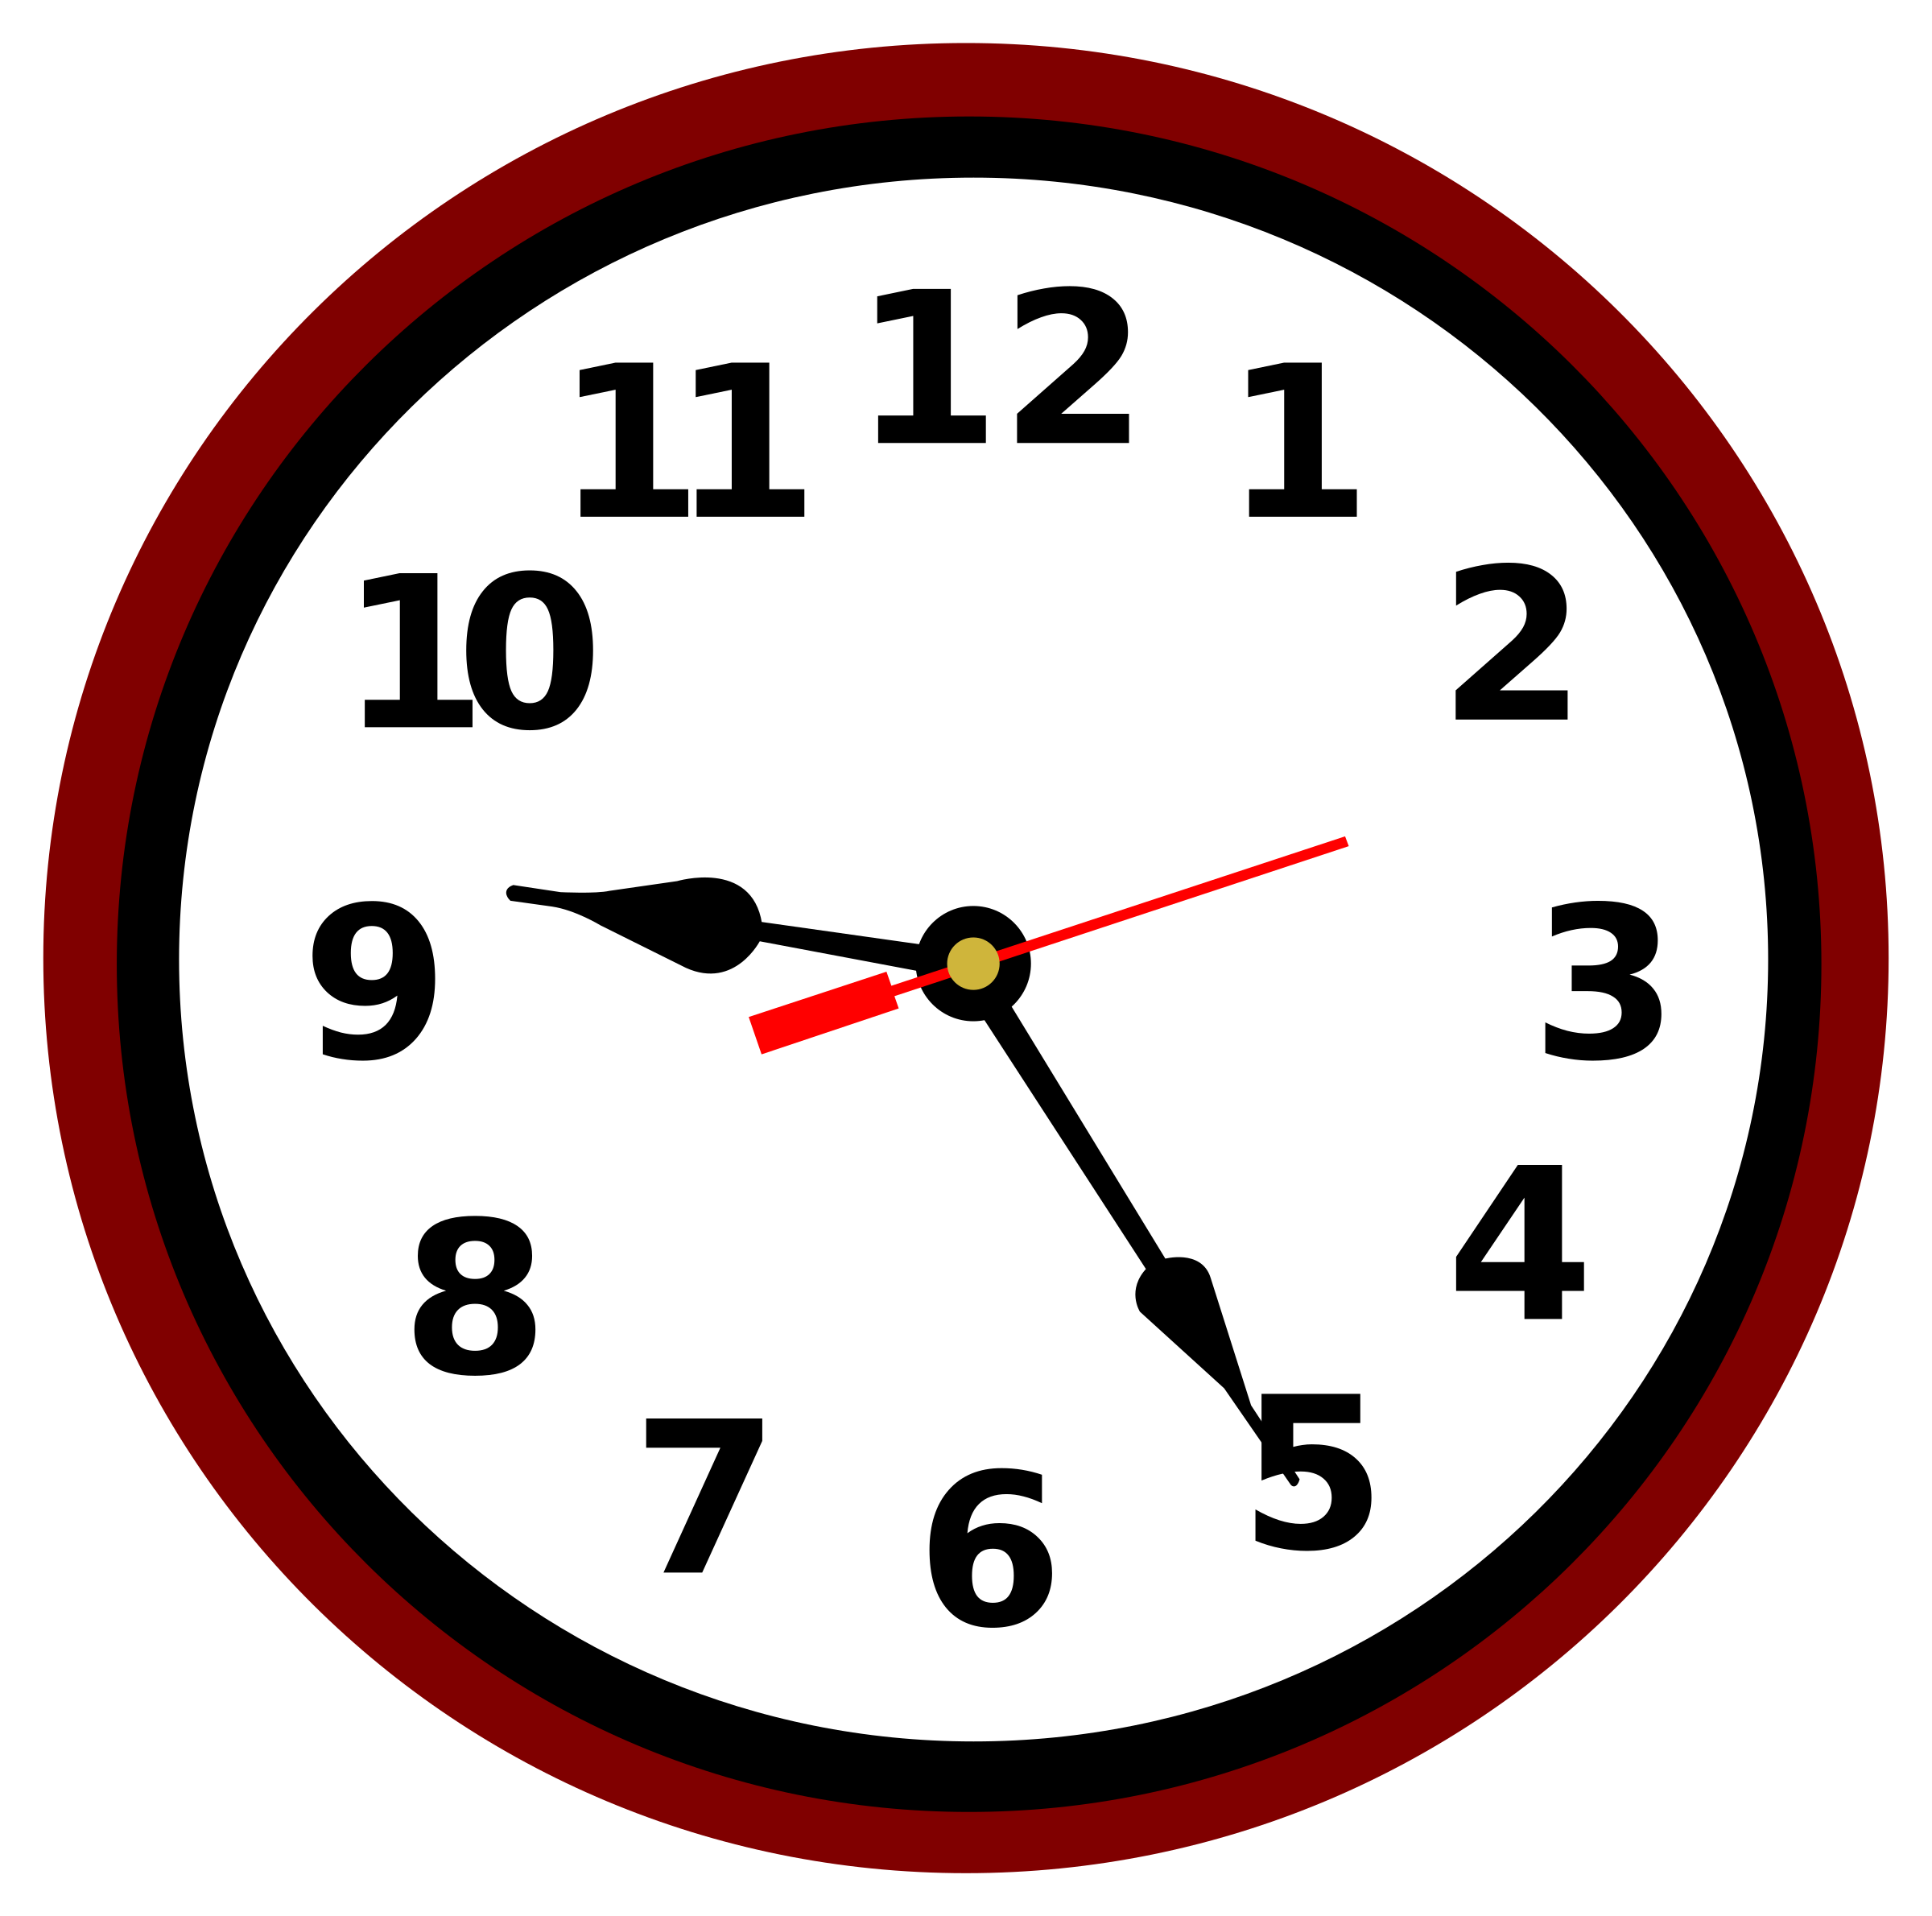

Make sure you are seeing the right person. Many minor conditions and ailments such as hay fever, insect bites, dry skin, conjunctivitis, medication queries and sore throats can be dealt with by your Pharmacist or by one of our Nurse Practitioners. If you need a nursing procedure then you need to see a practice nurse. If you need a travel jab you need an appointment in the Travel Clinic. . If you can give our reception staff brief details of your problem or request, they are trained to guide you to the correct person. And if you feel you need to speak to someone about an emotional issue, then throughout England and Wales there is a service called IAPT (Improving Access to Psychological Therapies), which is a free talking therapy service. If you are unsure who to see, ring 111, which is available 24 hours a day
So if you do decide you need to be seen, how can you get the most out of an appointment?
Please turn up on time. GPs run late but if you are late, then your ten-minute slot has gone and it may mean a rushed or fruitless appointment.
Feel free to bring a friend or relative. It can be helpful to have someone with you for support. Patients under the age of 14 should be accompanied by a parent or guardian.
Get it all out at the start. Write down what you want to discuss beforehand. If you have two items to discuss, list them at the beginning rather than saying, ‘Ooh, while I’m here…’ If you list them at the start, the GP can plan out the time.
Get to the point. The quicker you mention why you’re there, the more time the GP has to deal with your problem. This can be quite difficult with emotional problems, as some people find it hard to open up, but as for the rest, it’s best to get on with it. The GP will tease out what he or she needs from you in terms of more information.
Bring your diary. First, you can jot down notes as an aide-memoire. Second, if you can tell us exactly what happened and when, that makes our job much easier. And do tell the GP what you have tried, e.g. ‘I took paracetamol and it didn’t help…’ Certain words to describe your symptoms may help us identify the problem more quickly. Is your pain dull or sharp? Does it burn or throb? Does your headache feel like a tight band or is it sharp and stabbing? What are you unable to do?
Be prepared to be examined. Please wear clothing that is easy to remove.
Ask questions. If you don’t understand something, ask the doctor.
Make use of the primary care team. The GP is only a cog in the large well-oiled machine that is a GP surgery. You’ll save him/her and yourself a lot of time if you pick the right part of that machine. Chasing a referral to the hospital? Ring the hospital secretary. Need a blood pressure check? Maybe you could see the nurse. Need to see a counsellor? Ask reception if you can refer yourself. Worried about your toddler’s weight? See the health visitor first. Many services do not need you to see the GP.
Don’t expect us to solve everything in one visit. We live in a convenience culture, but medicine can be a complex business. Occasionally, you will need to wait for referrals to a specialist or try a treatment to see how you get on.
Don’t assume you can have what you want. NHS general practice was set up to deal with people’s health care needs. The rise of consumerism, medical advances and private clinics have meant that patients ask for some tests or procedures that aren’t clinically necessary or that there isn’t enough evidence to support with taxpayers’ money.
Don’t think that seeing patients is all a GP does. You may find your GP often runs late. This may be because he/she is on the phone to another doctor, admitting someone to hospital, or getting constant interruptions — home visit requests, prescription amendments, urgent messages about patients from relatives, safeguarding issues, calls from the hospital or coroner, queries from a pharmacist, urgent letters and results. Surveys indicate that GPs and patients would like longer appointments, but until the national shortage of GPs is addressed this will be difficult to achieve.
Finally, please ask a dentist for matters about your teeth.

