PPG Report and Action Plan 2015/16
Name of Practice: Quarter Jack Surgery
Practice Population: | See attached Fig 1
Membership of PPG: | Due to poor responses from emailing our virtual patient reference group last year we now place more emphasis on evaluating our F&F comments, NHS Choices comments and survey comments. We have also now changed our registration form to advise patients that they will automatically be enrolled into the PRG with an option to opt out if they wish. We do not view this in a negative manner as the comments we receive are 90% positive although we are always open to improvement. The last correspondence we had with our virtual group produced only three email responses and therefore we have engaged with our ‘friends of the practice’ who are also part of the face to face patient reference group to discuss an action plan for 2015/16 of which they have had extensive input.  Membership of our PRG comprises 65 people. 27 (41%) are male and 33 (59%) are female.  6 are carers (9%)  Ethnicity = British 42 (65%), British/mixed 6 (10%) and 17 unknown (25%)  Age Range = 17-25 = 2 (3%), 26-45 = 19 (29%). 46-60 = 15 (23%), 61-80 = 24 (37%) and 81+ = 5 (8%)
Information Analysed: | Our Friends & Family Test reports are positive and over the year we have attained a high percentage of satisfaction from our patients. We also take the opportunity to give these out in paper format in the waiting room so that patients can complete whilst visiting the practice. Please see Fig 2 for annual satisfaction rates plus a selection of comments received.  NHS Choices tend to mainly attract negative comments to practices. Our policy is to always respond to any comments and in particular are invited to contact the Practice Manager to discuss their issues. This is effective and having spoken to two patients who posted negative comments this was found to be their misunderstanding of systems within the practice. Unfortunately, those patients do not go back on to NHS Choices to remove the comments which are then negative to the practice scoring. Several positive comments have been added to NHS Choices this year.  The annual GP Survey shows that the practice is over both the local CCG and national average in all areas except two:  - we are slightly under the local CCG average but over the national average on waiting times i.e. 69% usually wait 15 mins or less after their appointment time to be seen  - 56% feel they do not normally have to wait too long to be seen the practice is below the local CCG average of 63% and under the national average of 58%  We have taken this feedback as an element to our planning of a new website which may well provide patients with information to avoid having to be seen in the practice. We already provide Same Day Clinics with our two nurse practitioners. As patients’ needs become more complex the 10 minute appointment is challenging for GPs to provide a complete consultation within this timescale.
Areas for improvements identified: | Based on the above & discussions with PRG the practice invited a company called Silicon Practice to provide a demonstration on how they could improve our website. Members of the PRG were invited to the presentation and their feedback was obtained. The ‘Friends of the Practice’ also agreed to invest some funding into the website as they were very much of the opinion that this would improve the patient experience with the practice.
Action plan: | See QJS Action Plan
Summary of change: | The new practice website went live in February 2016. We are still building information on it but Google analytics show that there is a steady build of access to the site.
Description of how patients have been engaged with this: | Consultation with PRG who were advised of survey results and consulted regarding new website.  PRG members invited to attend demonstration (Chair was elected to represent) and provide feedback.  Once implemented:  Advertised to patients in the waiting room by on screen information.  Advertised to patients by way of newsletters (see Fig 3)  Advised on new website by way of ‘Welcome to new website’ also inviting feedback and comments on how we can improve it.  Letter written to all patients on virtual group to advise of action plan for 2015/16.  Email correspondence with Friends/PRG  (See attached)

FIG 1 – QJS Population
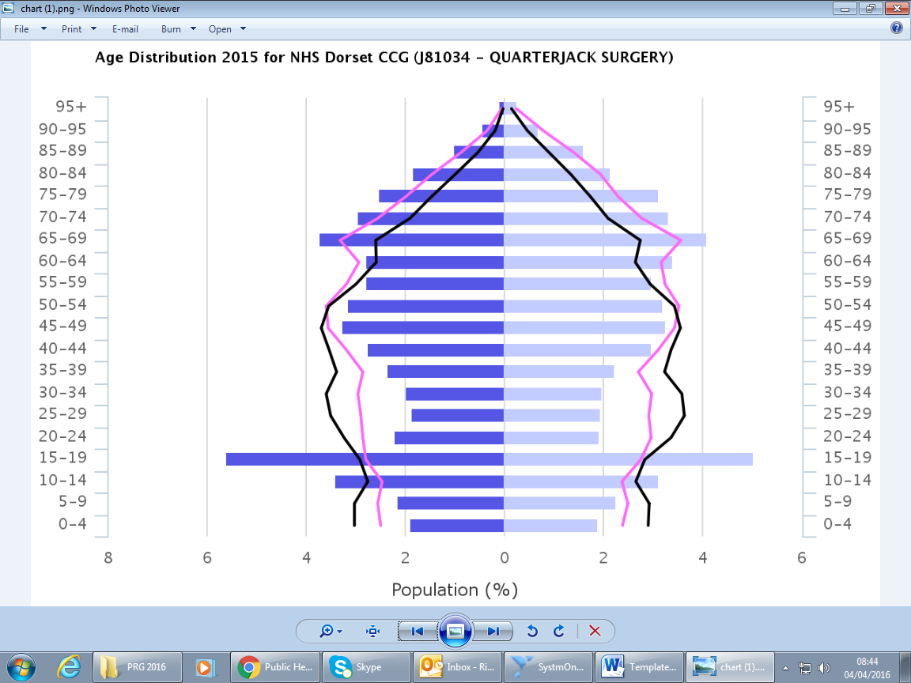

Fig 2 – Quarter Jack Surgery Friends & Family Response 2015/16
Likely to Unlikely to Patients
Recommend Recommend Surveyed
May 2015 100% 0% 17
June 2015 87% 1% 89
July 2015 90% 0% 20
August 2015 96% 0% 52
September 2015 100% 0% 13
October 2015 87% 2% 41
November 2015 66% 6% 15
December 2015 94% 0% 36
January 2016` 100% 0% 19
February 2016 94% 2% 39
March 2016 93% 0% 15

Note: The percentages above can be skewed by some of the inappropriate comments eg. children playing on the ipad or a low month on patients participating in the survey.

Comments from May 2015 survey:
Can you tell us why you gave that response?
I find the Drs and staff here are really friendly
Because it's a happy environment
The surgery staff are always helpful and the doctors caring
I would like to thank you all for an outstanding and friendly service to our community. This includes all staff. I hear so many poor reviews of other surgeries but I am always proud to say we do not have these issues in Wimborne Quarter Jack. Also the communication between Boots and doctors is second to none.
I have been registered at the practice for around 13 years and have always received excellent patient focused care for both myself and my family. The GP's & Nurses (Midwives/Health Visitors) are all caring, professional and take time to listen/explain despite any pressures they may be experiencing
Very quick appointments, friendly service and easy to access
Because I always felt supported, by secretaries by the team and Dr Tan, receptionists would expect better service.
you are just very very "good"
Excellent surgery
Understanding doctors
Efficient service
Kind friendly and helpful staff
Good service

Comments from February 2016 survey:
Been treated well by Doctor Redman & Nurses, and since my wife died have had great support.
The staff are welcoming G.P's are understanding and listen. Good service.
My doctor actually LISTENS to me and the rest of the staff without exception are polite, kind and helpful
No
The Quarter Jack surgery has a very good team of nurses and doctors who work under difficult circumstances because the NHS has undergone a lot of changes that have made giving patients the best of care so much more testing for surgeries.
Never run on time
Good seating etc. car park rather small.
Nice decor & lovely people
Generally good service, I do struggle to get through on phone because I work. Its engaged in a morning and closed at lunch!
Had good service today (if running slightly late)
Been with Quarter Jack my entire life and have always been given good advice and have always been offered a
professional/understanding response.
Good friendly service.
Because of the service experienced
Appointment on time. Pleasant manner. Efficient.
Excellent service. Both my mother & I have received very good care when we needed it.
Been with The Quarter Jack Surgery for 38 years and had no complaints found excellent service and all doctors & nurses very knowledgeable and efficient.
Helpful but not particularly quick
It is very difficult to get appointments when you need them, but generally the Drs are good when you see them although it should be easier to get CT scans sooner.
They are always helpful and try to get an appointment as soon as possible.
Prompt, friendly service.
Because all the staff are wonderful. You are never kept waiting & everyone is happy to solve your problems :)
All Drs, nurses & staff extremely caring, considerate & efficient. There isn't anything they won't do to help their patients in every situation.
Because i've always had great service
I have been at this practice for many years and have always been satisfied with the level of service - it cannot be faulted
Can never get an appointment.
Good service - Helpful team and doctor.
Friendly staff, great GP
Listened to me & reassured me on my health problems. Also constructive advice on future care
The treatment and follow up has been excellent by my doctor.
All happens without fuss
Receptionist very helpful
I think the practice is well managed and accommodating
Everyone is always very friendly & helpful. Thank you.
Have always been treated with courtesy and efficiency
Friendly, efficient service from Practice Nurse & GP. But lengthy waiting time for GP Appointment

GP Patient Survey
See link for QJS Survey results https://gp-patient.co.uk/practices/J81034 as discussed above.

Evidence of engagement with patient group:
Letter to PRG members dated 15.12.15
Email from Chair of PRG to PRG group reference new website
Copy of Minutes of the ‘Friends of the Practice’ highlighting website
Newsletter to Patients

